**PIZZA SALES SQL QUERIES**

**1.KEY PERFORMANCE INDICATORS-KPI’s**

**A. Total revenue**

SELECT SUM(total_price) AS TOTAL_REVENUE from pizza_sales

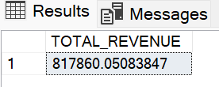

**B. Average order Value**

SELECT sum (total_price)/count(distinct order_id)as Avg_Order_value from pizza_sales

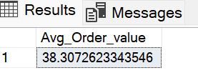

**C. Total Pizzas Sold**

select sum(quantity) as Total_pizza from pizza_sales

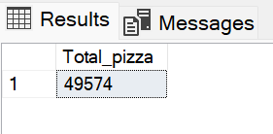

**D. Total Order**

select count (distinct order_id) as Total_Orders from pizza_sales

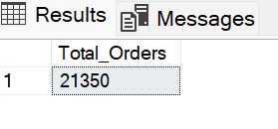

**E. Average Pizzas Per Order**

select cast(cast(sum(quantity)as decimal(10,2))/

cast(count(distinct order_id) as decimal (10,2))

as decimal(10,2))as Avg_Pizzas_per_Order from pizza_sales

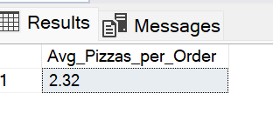

**2.DAILY TREND OF TOTAL ORDERS**

select datename(DW, order_date) as order_day, count(distinct order_id) as Total_orders from pizza_sales

group by datename(DW, order_date)

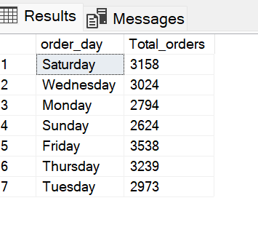

**3. MONTHLY TREND FOR TOTAL ORDERS**

select datename(MONTH,order_date) as Month_Name,

count(distinct order_id) as Total_orders from pizza_sales

group by datename(MONTH,order_date)

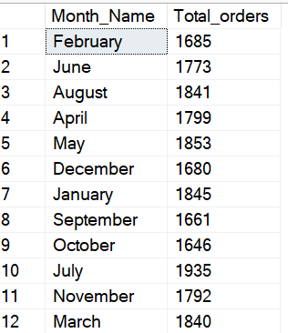

# IN DESCENDING ORDER WRT TOTAL_ORDERS

select datename(MONTH,order_date) as Month_Name,

count(distinct order_id) as Total_orders from pizza_sales

group by datename(MONTH,order_date)

order by Total_orders DESC

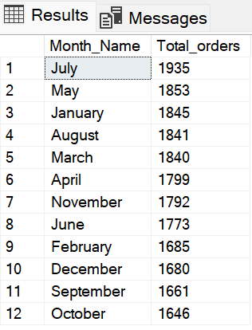

**4. PERCENTAGE**

**A. PERCENTAGE SALES BY PIZZA CATEGORY**

select pizza_category, sum(total_price)*100/(select sum(total_price) from pizza_sales) as pct

from pizza_sales

group by pizza_category

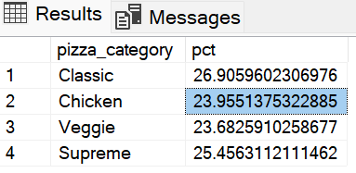

Note:

select pizza_category, sum(total_price)*100/(select sum(total_price) from pizza_sales) from pizza_sales where month(order_date)=1 as pct

from pizza_sales

where month(order_date)=1

group by pizza_category

**B. PERCENTAGE SALES BY PIZZA SIZE**

select pizza_size, sum(total_price)as Total_Sales,cast(sum(total_price)*100/

(select sum(total_price) from pizza_sales) as decimal(10,2)) as pct

from pizza_sales

group by pizza_size

order by pct DESC

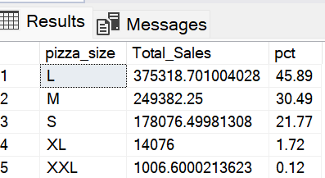

**C. TOP % BEST SELLERS BY TOTAL REVENUE**

select top 5pizza_name,cast(sum(total_price) as decimal(10,2))

as total_revenue

from pizza_sales

group by pizza_name

order by total_revenue desc

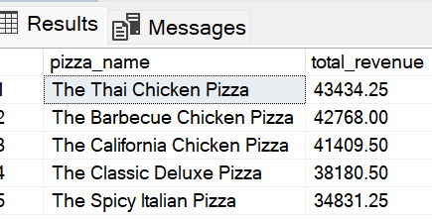

**D. TOP % BEST SELLERS BY TOTAL QUANTITY**

select top 5 pizza_name,cast(sum(quantity) as decimal(10,2))

as total_quantity

from pizza_sales

group by pizza_name

order by total_quantity desc

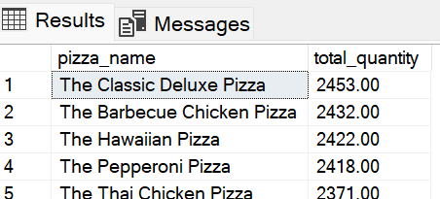

**E. TOP % BEST SELLERS BY TOTAL ORDERS**

select top 5 pizza_name,count(DISTINCT order_id)

as total_orders

from pizza_sales

group by pizza_name

order by total_orders desc

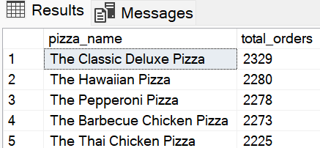

**F. BOTTOM % WORST SELLERS BY TOTAL REVENUE**

select top 5pizza_name,cast(sum(total_price) as decimal(10,2))

as total_revenue

from pizza_sales

group by pizza_name

order by total_revenue asc

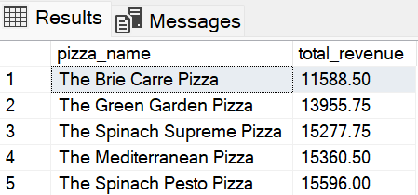

**G. BOTTOM % WORST SELLERS BY TOTAL QUANTITY**

select top 5 pizza_name,cast(sum(quantity) as decimal(10,2))

as total_quantity

from pizza_sales

group by pizza_name

order by total_quantity asc

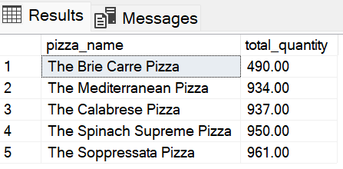

**H. BOTTOM % WORST SELLERS BY TOTAL ORDERS**

select top 5 pizza_name,count(DISTINCT order_id)

as total_orders

from pizza_sales

group by pizza_name

order by total_orders asc

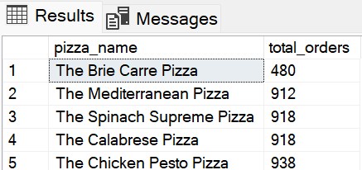

NOTE:USE CAST TO CONVERT IT TO DECIMAL.